Oracle Kubernetes Cluster - OCI ORM Stack

Prerequisites:

- Existing VCN for OKE Cluster
- Existing Subnet for Service Load Balancer
- Existing Subnet for Kubernetes API Endpoint
- Existing Subnet for Worker Node

Specifications:

Step 1: Login to the OCI console and navigate to
OCI Console >> Developer Services >> Stacks

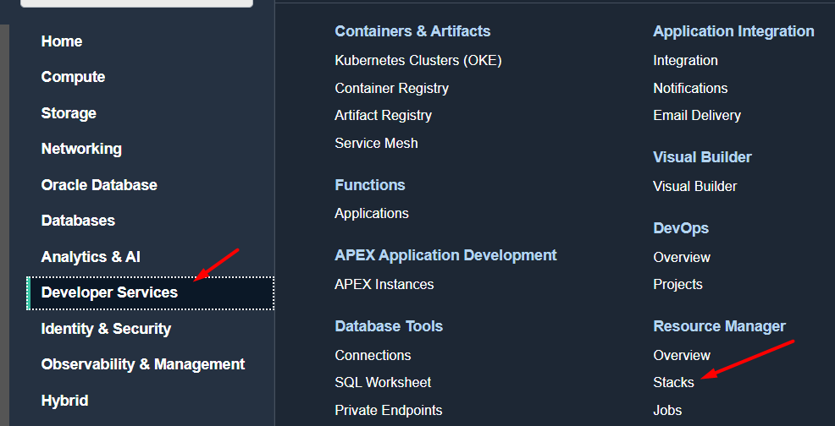

Step 2: Click on create stack

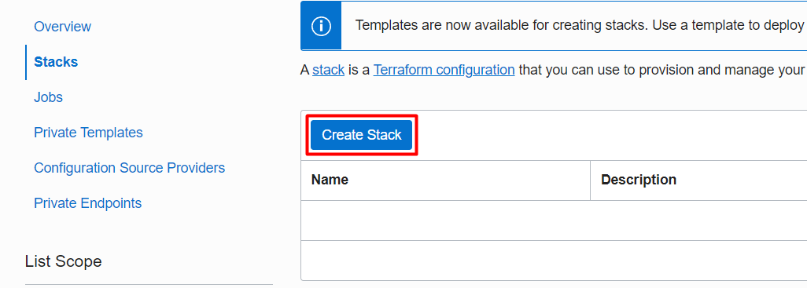

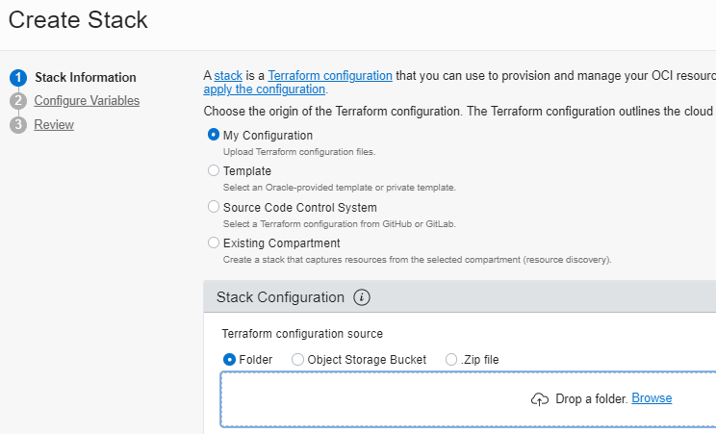

Step 3: In Stack Configuration, upload the folder or ZIP file that contains the terraform files for OKE.
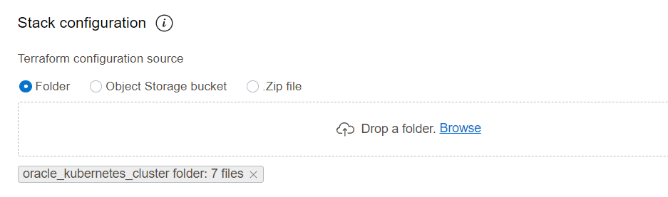

Step 4: Leave default for Working Directory, provide optional name, choose the compartment where you want to create the stack and click Next.

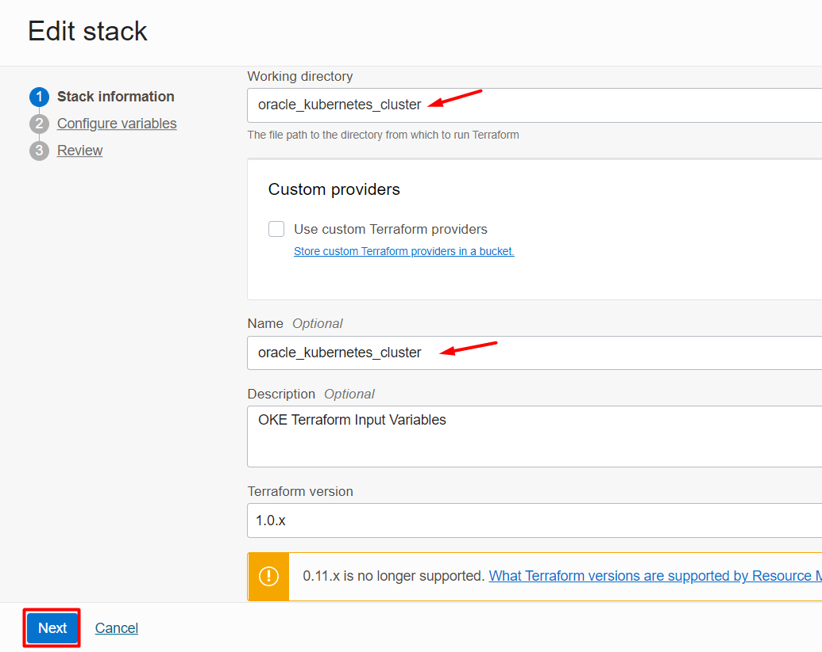

Step 5: Provide the following variables

- Check the Checkbox for Create Private OKE Cluster ? - If checked Private OKE cluster will be created, if unchecked public OKE Cluster will be created
- OKE Display Name
- Image OCID to be used for OKE Worker Nodes

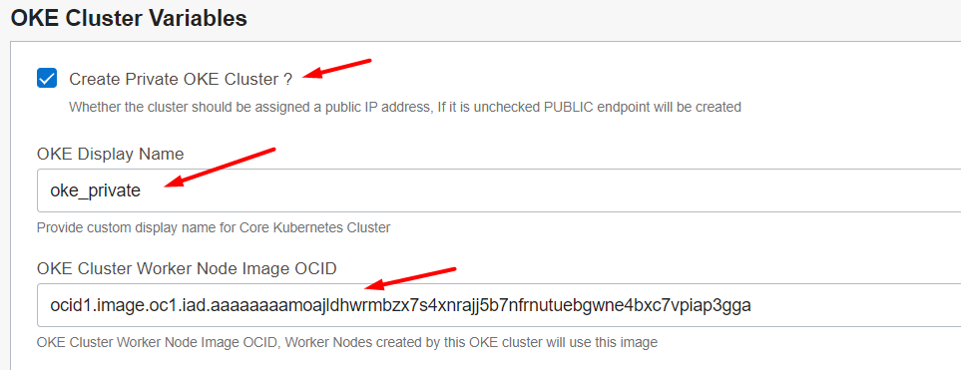

Step 6: Provide the following variables:

- Worker Node Boot Volume Size in GB
- Number of Node Pools to create for OKE Cluster
- Number of Worker Nodes to create for OKE Cluster

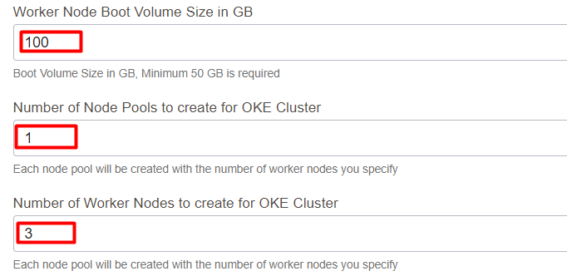

Step 7: Provide the following variables:

- OKE Cluster Pods CIDR Block
- OKE Cluster Services CIDR Block

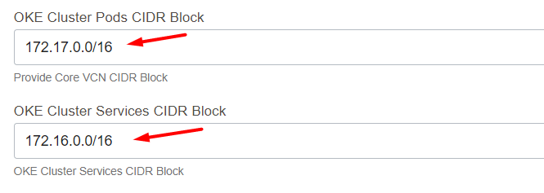

Step 8: Provide the following variables:

- OKE Cluster Worker Node Shape
- If you provide flexible shape then you will be asked to provide below
- OKE Cluster Worker Node Memory Size in GB
- OKE Cluster Worker Node OCPU Count
- If you check for Use Custom SSH Public Key for Worker Nodes ? then
- Provide the SSH Public Key for Worker Nodes
OR
- Terraform will generate the RSA private and public keys

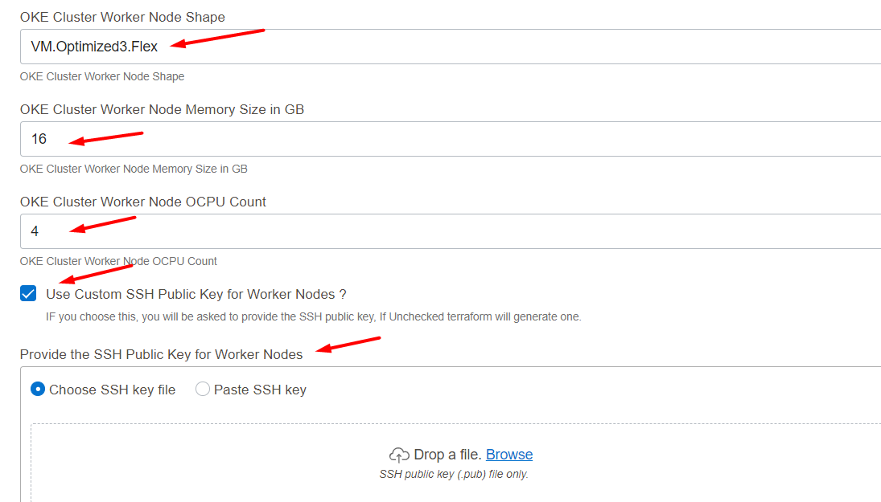

Step 9 : Provide the following variables for Network Configuration:

- Select the VCN Compartment
- Select the VCN
- Select the Subnet Compartment
- Select the Subnet for Load Balancer
- Select the Subnet for Worker Nodes
- Select the Subnet for Kubernetes API Endpoint

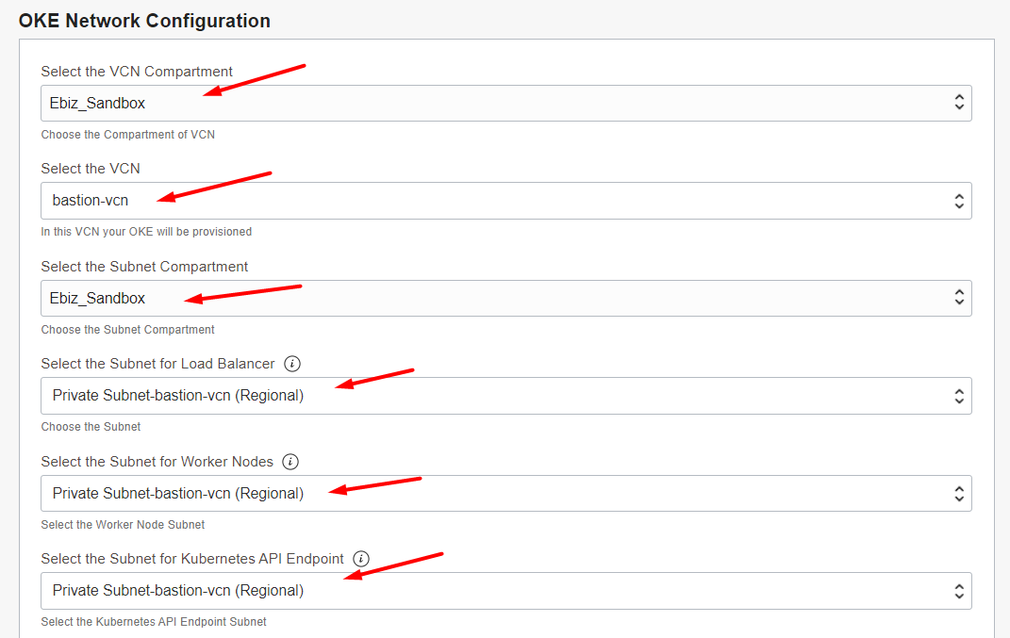

Step 10: Provide the following values

- Select the target compartment to deploy the OKE Cluster
- Region is optional

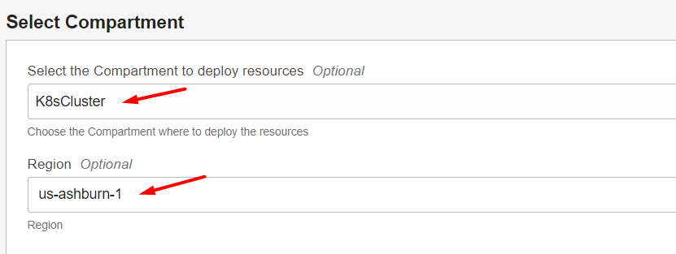

Step 11: You can attach the tags if it is required then click on Next.

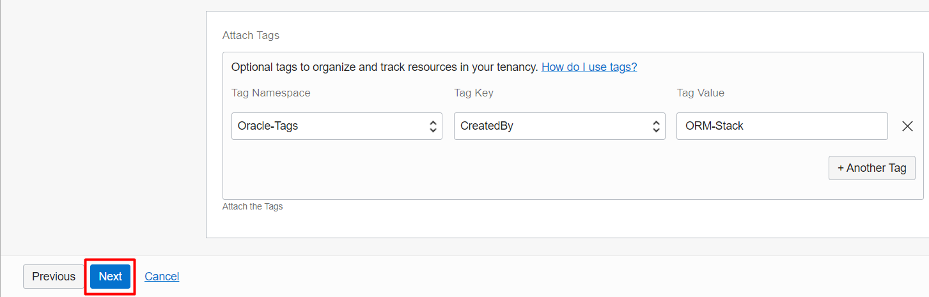

Step 12: Review all the values you have provided and click Create.

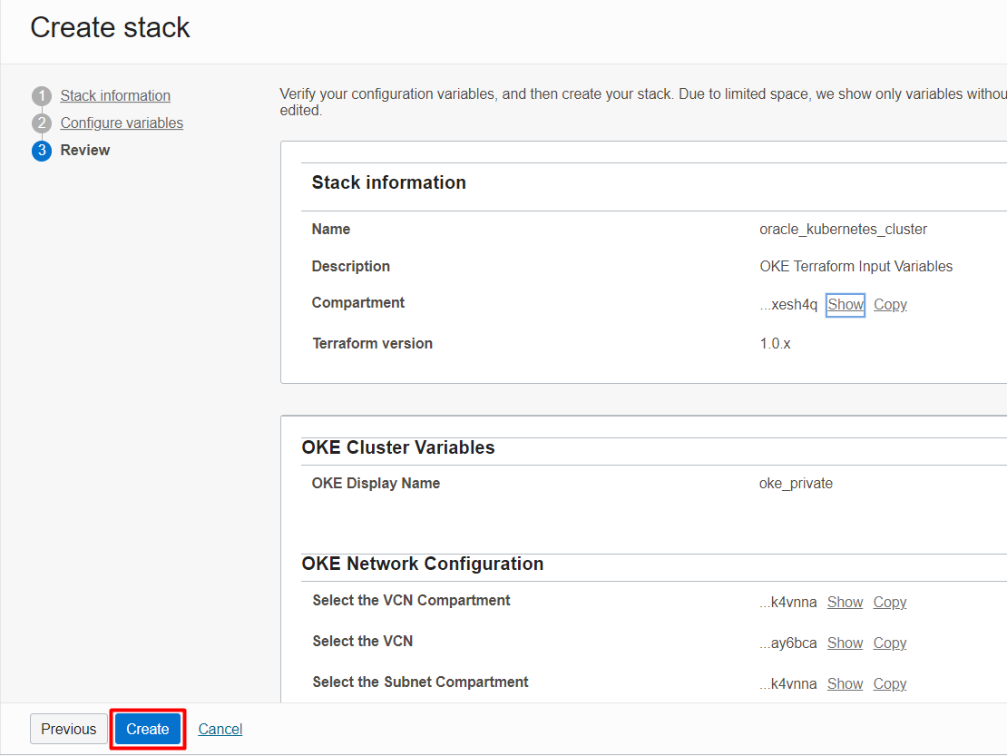

Step 13: Click on Plan and review the logs.
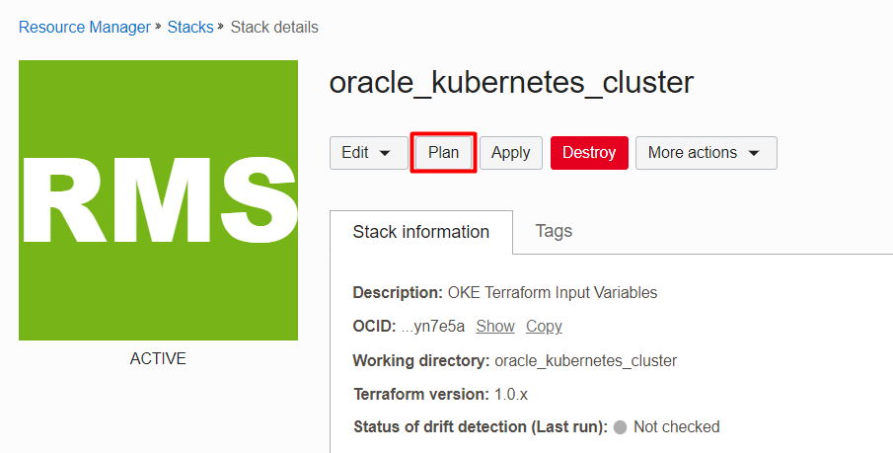

Step 14: Once the Plan is executed, check the plan logs and click on Apply action to create OKE Cluster.

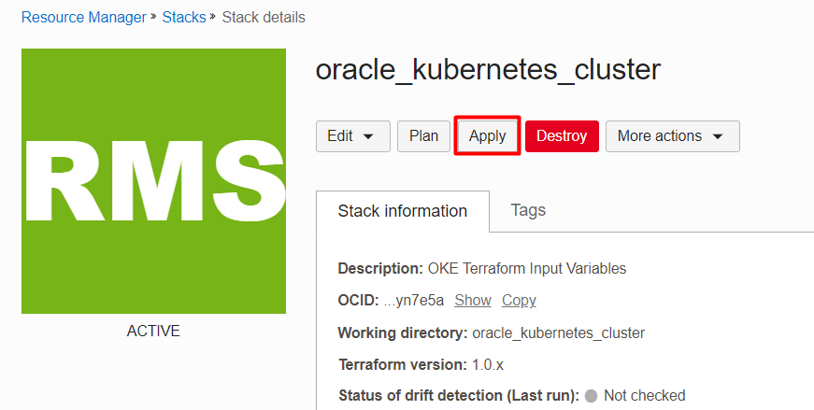

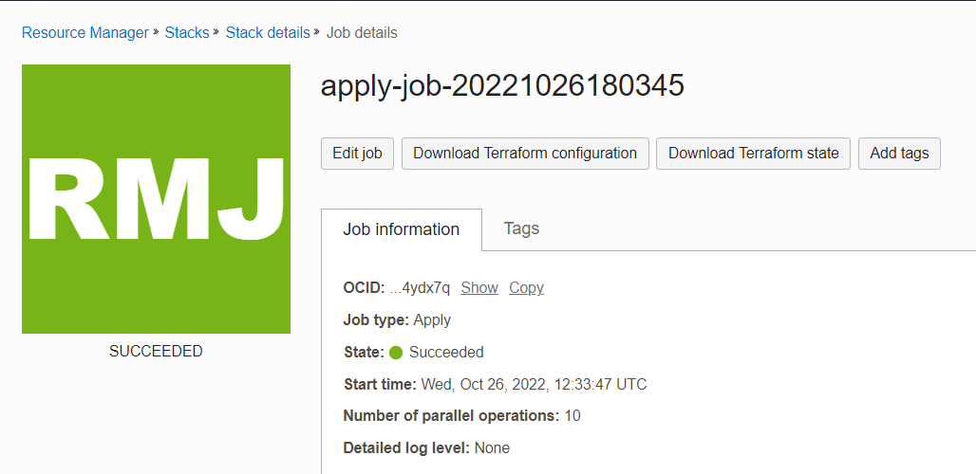

Step 15: If the apply job is successful, Navigate to Developer Services >> Kubernetes Clusters(OKE) and OKE Cluster will be created.

